Oprah Winfrey Biography

A famous American talk show host, actress, producer and philanthropist, Oprah Winfrey is most renowned for ‘The Oprah Winfrey Show’. To know more about her childhood, career, profile and timeline read on

 | Quick Facts
Also Known As |  | Oprah, Oprah Gail Winfrey, O, Deepak Oprah,
 |  | Lady O, Orpah Gail Winfrey, The Preacher, The
 |  | Little Speaker
Famous as |  | Media proprietor
Nationality |  | American
Born on |  | 29 January 1954 AD
Height |  | 1.69 m
Zodiac Sign |  | Aquarius
Born in |  | Kosciusko, Mississippi, United States
Father |  | Vernon Winfrey
Mother |  | Vernita Lee
Siblings |  | Patricia Lloyd, Jeffrey Lee, Patricia Lee
Spouse |  | Stedman Graham
Education |  | Tennessee State University, East Literature
 |  | Magnet School, Nicolet High School
Founder/Co-Founder |  | Oprah's Angel Network, Family for Better Lives,
 |  | Harpo Productions, Oprah Winfrey Network,
 |  | Oprah Winfrey Leadership Academy for Girls,
 |  | Oxygen, Oprah Winfrey Foundation
Net worth |  | $3 billion as of 2017
Awards |  | Kennedy Center Honors - 2010
 |  | Jean Hersholt Humanitarian Award - 2011
 |  | Daytime Emmy Award for Outstanding Special
 |  | Class Series - 2014
 |  | People's Choice Award for Favorite Talk Show
 |  | Host - 2004-1988
 |  | peabody award - 1996
 |  | NAACP Image Award for Entertainer of the Year -
 |  | 1989
 |  | Bob Hope Humanitarian Award - 2002

www.thefamouspeople.com Page 1 / 6

Quick Facts

Daytime Emmy Award for Outstanding Talk Show

Host - 1998-1995-1994

People's Choice Award for Favorite Female TV

Performer - 1998-1997

Anisfield-Wolf Book Award - 2010

spingarn medal - 2000

Daytime Emmy Award for Outstanding Talk Show

- 1997-1996-1995

Producers Guild of America Award - Stanley

Kramer Award - 2008

TCA Career Achievement Award - 2011

NAACP Image Award – Hall of Fame Award -

2005

International Emmy Award for Founders - 2005

Primetime Emmy Award for Outstanding

Television Movie - 2000

Daytime Emmy Award for Outstanding

Children/Youth/Family Special - 1993

Producers Guild of America Award - David L.

Wolper Producer of the Year Award in Long-Form

Television - 2000

Medal of Distingui

hed Contribution to American Letters - 1999
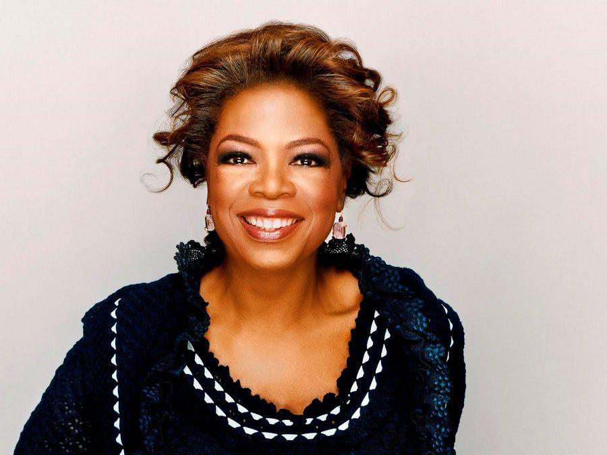

Oprah Winfrey is an internationally influential self-made billionaire African-American woman. Born to an unwed mother who had a short relationship with a soldier stationed nearby, Oprah grew up in dire

www.thefamouspeople.com Page 2 / 6
poverty, and was primarily raised by her grandmother. Sexually abused and mistreated as a child, Winfrey rose above adversity to focus on her primary and high school education. After developing a close relationship with a young man and winning a local beauty pageant got her a chance to shine at a local radio station, Winfrey knew that she wanted to work in the broadcast industry. Despite failing one key interview, she persevered and moved across the country to secure a job as a television reporter. Although she never quite adapted to the job, and was later fired, she gained enough experience to be given her own morning talk show. After Winfrey delivered solid ratings, she moved across the country to host a new talk show. After the ratings exploded, she was given control over her own show, which soon became a wildly popular national phenomenon. Winfrey rapidly expanded her media network, launching a magazine, television channel and radio network, and is now considered to be one of the most influential and powerful women on the planet

Childhood & Early Life:

Oprah Gail Winfrey was born on January 29, 1954 in Kosciusko, Mississippi. Her mother was Vernita Lee, who lived on a small family farm. Oprah's biological father, Vernon Winfrey, was a soldier temporarily stationed at a nearby base. Oprah was raised by her grandmother, Hattie Mae Lee.

Oprah stated that as a child her "only friends" were the animals on her family farm. She gave her first public recital at a local church when she was just 3 years old.

She shuttled between different caregivers throughout her childhood, and attended Nashville East High School in Nashville, Tennessee. In her senior year, Oprah was chosen to read the news on a local radio station. In the same year, she won the Miss Black Tennessee contest.

Career:

When she was still a teenager, the local CBS television station in Nashville, Tennessee offered her a job as a co-anchor. She turned it down three times. At age 19, Oprah Winfrey said yes after the fourth offer.

She failed the interview, but instead was offered a job as a full-time reporter for a Baltimore television news channel. She did poorly as a reporter, and by age 22 she was fired from the news division.

The director of the station gave Winfrey a boost by selecting her to anchor a morning talk show entitled ‘People are Talking’. For the next seven years, her talk show enjoyed excellent ratings.

In 1981, she moved to Chicago to host a talk show entitled ‘A.M. Chicago’. Four years later, after a tremendous boost in the ratings, the producers changed the name to ‘The Oprah Winfrey Show’.

In 1985, Winfrey performed as an actress in the movie 'The Color Purple'.

On September 8, 1986, ‘The Oprah Winfrey Show’ was broadcast nationally. In the same year,

www.thefamouspeople.com Page 3 / 6
she founded ‘Harpo Studios’.

In June of 1987, her show won three ‘Daytime Emmy Awards’. The following year, it won an additional ‘Daytime Emmy for Outstanding Talk Show’.

In 1989, she produced and co-starred in the miniseries 'The Women of Brewster Place' and 'Brewster Place'. In the same year, her company ‘Harpo Productions’ began producing ‘The Oprah Winfrey Show’.

In 1993, she conducted an interview with Michael Jackson. The episode became the most watched interview ever, and fourth most watched event in American television.

In 1996, she launched ‘Oprah's Book Club’, a talk show meant for book discussions. Books recommended by Winfrey sold millions of additional copies.

In 1997, she played the role of a therapist in an episode of the sitcom 'Ellen'.

In 1998, she produced and starred in the movie 'Beloved'. In the same year, she was sued by Texas cattlemen for allegedly making defamatory remarks about hamburgers.

The same year this talk show host started ‘Oprah’s Angel Network’ which provided funds to charitable and non-profit organizations.

In 2002, she launched ‘O, the Oprah Magazine’. It was later confirmed as the most successful start-up ever in the magazine industry.

On December 1, 2005, she was a guest on the 'Late Show with David Letterman', which some critics proclaimed was the 'television event of the decade'.

In 2006, she provided the voice for the animated film 'Charlotte's Web'. In the same year, she launched ‘Oprah Radio’, a channel on ‘XM Satellite Radio’.

In 2007, she provided the voice for Judge Bumbleden in the film 'Bee Movie'.

In 2008, the talented artist endorsed Barack Obama in the presidential election. Her public support was considered a key factor in Obama's ultimate victory.

In 2009, she provided the voice for Eudora in the film 'The Princess and the Frog'.

Major Works:

Oprah Winfrey is the richest self-made woman in America and one of the most influential and powerful women in the world.

Awards & Achievements:

In 2000, this talented artist was honored with the ‘Spingarn Medal’ from the NAACP.

In 2013, she was awarded the ‘Presidential Medal of Freedom’. She has also won dozens of awards and recognitions for her broadcasting and acting career.

Personal Life & Legacy:

www.thefamouspeople.com Page 4 / 6
Winfrey has publicly disclosed that she was raped by a family relative when she was 9 years old. She also disclosed that she gave birth at age 14, and that her child died in infancy. Winfrey has used her personal experience to campaign for support groups to help survivors of sexual abuse.

She lives on a property named ‘The Promised Land’ in California. She has dated several celebrities, including John Tesh and Roger Ebert, but has never married. She has officially been in a relationship with her long-time boyfriend Stedman Graham since 1986.

The philanthropic talk show host has given over 400 scholarships to Morehouse College. She has also been ranked as among the 50 most generous Americans.

Net Worth:

In 2014, this media proprietor was reported to have a net worth of over 2.9 billion dollars.

Trivia:

This talented talk show host is now considered to be the wealthiest African-American woman in the United States

Quotes By Oprah Winfrey


www.thefamouspeople.com Page 5 / 6


www.thefamouspeople.com Page 6 / 6

Powered by TCPDF (www.tcpdf.org)

